Project Summary:

International Adoption Statistics.

Datasets:

Department of State Annual Reports on Intercountry Adoption (unreadable pdf)

Department of Health & Human Services – domestic foster care & adoption (potentally readable pdf)

US Census (csv)

Basic Inquiries:

Adoptions in US vs. Abroad

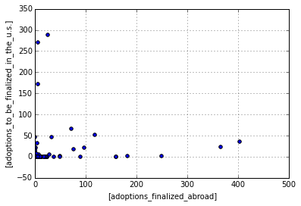

Adoptions in US vs. Abroad showing Hague vs. non-Hague

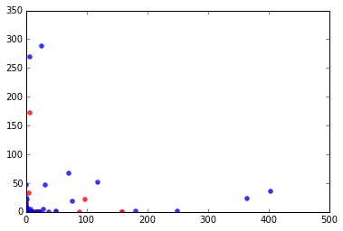

Hague is in blue. Although there doesn’t seem to be a specific relation, per se, we can see that the outliers are generally not Hague convention countries.